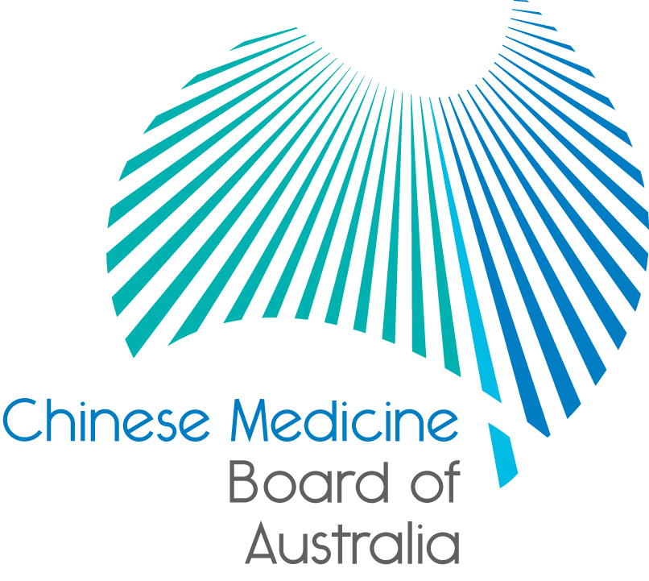

Communiqué: Chinese Medicine Board of Australia

November 2017 meeting

The 70th meeting of the Chinese Medicine Board of Australia (the Board) was held on 14 November 2017 in Melbourne.

This communiqué provides key decisions made at the meeting. It is also published on the Board’s [website](http://www.chinesemedicineboard.gov.au/) and an announcement via email is sent to a broad range of stakeholders. Please forward the communiqué to colleagues who may be interested in the Board’s work.

Upcoming forums: invitation for Chinese medicine practitioners, students and stakeholders

The Board is inviting Chinese medicine practitioners, students and stakeholders of Chinese medicine to attend information forums being held around Australia.

| **State** | **Dates** | **Time** |
| --- | --- | --- |
| **Adelaide,**  **South Australia** | **Monday 11 December**  Adelaide Karstens  19 Young Street, Adelaide | 6:00pm to 7:30pm |

**The Board will also be in Perth, Western Australia on Monday 26 March 2018.**

There will be a Board presentation and time for questions and discussion, then networking and light refreshments.

Please put this date in your diary for planning and when you receive an invitation or see the details on the website for your location, RSVP about your attendance.

Graduates invited to apply online for general registration

AHPRA is calling for final-year students of Chinese medicine to apply for registration online.

Those on the Student Register who will complete their approved program of study at the end of 2017 have been sent an email inviting them to [apply online](http://www.ahpra.gov.au/Registration/Graduate-Applications/Apply-Online.aspx) for registration four to six weeks before finishing their course.

Students are encouraged to read the information on AHPRA’s website under [Graduate applications](http://www.ahpra.gov.au/Registration/Graduate-Applications.aspx). Certain applicants will also need to apply for an [international criminal history check](http://www.ahpra.gov.au/Registration/Registration-Standards/Criminal-history.aspx).

Graduates can start practising as soon as their name is published on the [national register](http://www.ahpra.gov.au/Registration/Registers-of-Practitioners.aspx).

Chinese medicine practitioners have until 30 November to renew their registration on time

When completing renewal this year, Chinese medicine practitioners will be asked to check that their details are recorded correctly on the register. This extra step will help us to maintain the integrity of the national register, which helps to protect the public.

Renewal applications received in December will incur a late payment fee in addition to the annual renewal fee. This is outlined in the Health Practitioner Regulation National Law, as in force in each state and territory ([the National Law](http://www.ahpra.gov.au/About-AHPRA/What-We-Do/Legislation.aspx)). A [fees schedule](http://www.chinesemedicineboard.gov.au/Registration/Fees.aspx) is published on the Board’s website.

Chinese medicine practitioners, whose application for general registration is received on time or during the following one-month late period, can continue practising while their application is processed.

Practitioners who do not apply to renew their registration by 31 December 2017 will have lapsed registration. They will be removed from the [Register](http://www.ahpra.gov.au/Registration/Registers-of-Practitioners.aspx) and will not be able to practise the profession in Australia.

AHPRA’s annual report

The Annual Report for AHPRA and National Boards reveals how the Board has worked to protect the public in 2016/17. The report is a comprehensive record of the National Registration and Accreditation Scheme (the National Scheme) for the 12 months to 30 June 2017.

The Chinese medicine health workforce grew by 2.1% over the past year, to 4,860 total registrants, according to data released today in the 2016/17 annual report published by AHPRA and the National Boards.

The Annual Report is a comprehensive record of the National Registration and Accreditation Scheme (the National Scheme) for the 12 months to 30 June 2017.

While Chinese medicine practitioners constitute a relatively small proportion of the 678,983 registrants currently in the National Scheme, the profession continues to grow year on year.

In the coming weeks, AHPRA and the Board will also publish a summary of our work regulating Chinese medicine practitioners.

For more information visit the [Annual Report microsite](http://www.ahpra.gov.au/annualreport/2017) on the AHPRA website.

Guidelines go live - Guidelines for safe practice of Chinese herbal medicine come into effect

The Board is reminding Chinese medicine practitioners of their obligation to use the *Guidelines for safe practice of Chinese herbal medicine.*

The Board developed the guidelines to support the safe practice of Chinese herbal medicine and make sure that medication safety is a priority for the profession.

Development of the guidelines involved detailed consultation and input from a wide range of stakeholders.

The guidelines, which came into full effect on 12 November 2017 were published by the Board over two years ago to make sure that practitioners had enough time to become familiar with their content and start to use them when providing care to patients.

Under the guidelines practitioners are required to provide information in English on prescriptions and labels and:

* use clear and consistent herbal nomenclature
* record adequate details of Chinese herbal medicines in patient health records
* write prescriptions which contain adequate information
* ensure medicine labeling is accurate and informative, and
* ensure compounding and dispensing of medicines is precise and professional.

The Board has released resources to help Chinese medicine practitioners implement the guidelines:

* [Quick reference guide](http://www.chinesemedicineboard.gov.au/Codes-Guidelines/Guidelines-for-safe-practice.aspx)
* [FAQ](http://www.chinesemedicineboard.gov.au/Codes-Guidelines/FAQ.aspx)
* [User guide - Nomenclature compendium for Chinese herbal medicine](http://www.chinesemedicineboard.gov.au/Codes-Guidelines/Guidelines-for-safe-practice.aspx), and
* [Nomenclature list of commonly used Chinese herbal medicines](http://www.chinesemedicineboard.gov.au/documents/default.aspx?record=WD15%2f18746&dbid=AP&chksum=Cs%2baCFhYVrzbzL2%2bYnhtRA%3d%3d).

Update on the Independent Accreditation Systems Review

In October 2016 health ministers commissioned Professor Michael Woods, former Productivity Commissioner, to carry out the Independent Accreditation Systems Review (the Review). Following public consultations Professor Woods has prepared [draft recommendations](https://www.coaghealthcouncil.gov.au/Projects/Accreditation-Systems-Review) for ministers. Many of the reforms in his draft report would, in their current form, require significant changes to our legislation and how we manage the accreditation of courses leading to registration as well as assessment of internationally qualified practitioners.

In response to the draft recommendations, AHPRA and National Boards have published a joint submission to the Review on the [AHPRA website](http://www.ahpra.gov.au/Publications/Corporate-publications.aspx#ahprasubmission). In summary we propose that a more effective and efficient approach would be to make changes to roles of AHRPA, National Boards and Accreditation Councils, rather than create new regulatory bodies with the likely cost and complexity this could create. We believe that this would deliver the changes required to support the professional health workforce required by Australia.

The joint submission includes additional responses from four participating National Boards - Chiropractic, Medical, Optometry and Psychology. The Pharmacy Board made a separate [submission](http://www.pharmacyboard.gov.au/Accreditation.aspx) and has published this on their [website](http://www.pharmacyboard.gov.au/).

AHPRA and National Boards look forward to the Review’s final report and health ministers’ response in due course.  A news item including a high level summary of key aspects of the joint submission has been published on the [AHPRA website](http://www.ahpra.gov.au/News/2017-11-13-recommendation-to-imrove-accreditation.aspx).

Updating your contact details

To check or update the contact details you have lodged with AHPRA, access the online services panel for practitioners on the [homepage of the Board’s website](http://www.chinesemedicineboard.gov.au/) and click Update your contact details. Enter your user ID, date of birth and password (please note that your user ID is not your registration number). If you don’t remember your user ID or password, contact us [online](http://www.ahpra.gov.au/About-AHPRA/Contact-Us.aspx) or phone 1300 419 495 for help.

Follow AHPRA on social media

Connect with AHPRA on [Facebook](https://www.facebook.com/ahpra.gov.au/), [Twitter](https://twitter.com/AHPRA) or [LinkedIn](https://www.linkedin.com/company/australian-health-practitioner-regulation-agency) to receive information about important topics for your profession and participate in the discussion.

|  |  |  |
| --- | --- | --- |
| [cid:image001.png@01D29412.B22B9AD0](https://www.facebook.com/ahpra.gov.au/) | [cid:image002.png@01D29412.B22B9AD0](https://twitter.com/AHPRA) | [cid:image003.png@01D29412.B22B9AD0](https://www.linkedin.com/company/australian-health-practitioner-regulation-agency) |

Important information for practitioners

The Board publishes a range of information about registration, including its expectations of practitioners, at [www.chinesemedicineboard.gov.au](http://www.chinesemedicineboard.gov.au).

For more details or help with questions about your registration, notifications or other matters relevant to the National Scheme, refer to information published on [www.ahpra.gov.au](http://www.ahpra.gov.au) or [contact AHPRA](http://www.ahpra.gov.au/About-AHPRA/Contact-Us.aspx), send an [online enquiry form](https://www.ahpra.gov.au/About-AHPRA/Contact-Us/Make-an-Enquiry.aspx) or call on 1300 419 495.

Professor Charlie C Xue

Chair, Chinese Medicine Board of Australia

24 November 2017

[*The Chinese Medicine Board of Australia*](http://www.chinesemedicineboard.gov.au/) *is the regulator of Chinese medicine practitioners in Australia and acts to protect the public by ensuring that suitably qualified and competent Chinese medicine practitioners are registered. The Board is responsible for developing registration standards, codes and guidelines for Chinese medicine practitioners and managing notifications (complaints)* about Chinese medicine practitioners and Chinese medicine students. The Board does this through its powers under the Health Practitioner Regulation National Law, as in force in each state and territory, and the National Registration and Accreditation Scheme, supported by the Australian Health Practitioner Regulation Agency (AHPRA). The Board’s work in regulating Australia’s Chinese medicine practitioners in the public interest is underpinned by* [*regulatory principles*](https://www.ahpra.gov.au/About-AHPRA/Regulatory-principles.aspx)*, which encourage a responsive, risk-based approach to regulation.*

*\*Except in NSW and Qld which have co-regulatory arrangements.*