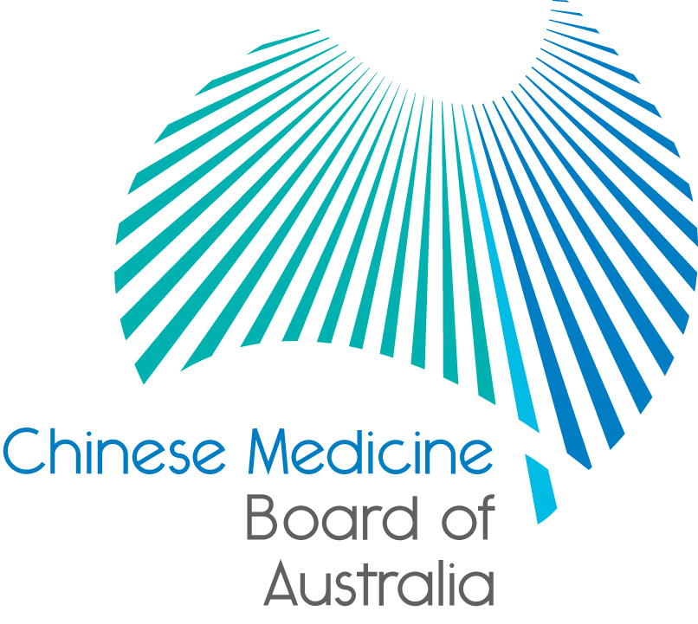

Communiqué: Chinese Medicine Board of Australia

June 2017 meeting

The 65th meeting of the Chinese Medicine Board of Australia (the Board) was held on 27 June 2017 in Melbourne. The Board did not hold a meeting in May 2017 as it was visiting its regulatory colleagues in China.

This communiqué provides key decisions made at the meeting. It is also published on the Board’s [website](http://www.chinesemedicineboard.gov.au/) and an announcement via email is sent to a broad range of stakeholders. Please forward the communiqué to colleagues who may be interested in the Board’s work.

Board member terms were due to expire on 30 June 2017

The process for enabling the Australian Health Workforce Ministerial Council to make the appointment decisions is progressing as quickly as possible. Despite best efforts, Ministers were not in a position to make a decision before the expiry of the current term.

Current serving members were advised that in accordance with the National Law1, their appointment will automatically continue after the scheduled expiry for a period of up to six months, until the Ministerial Council makes appointment decisions.

Upcoming forums: invitation for Chinese medicine practitioners, students and stakeholders

The National Board is inviting practitioners, students and stakeholders of Chinese medicine to attend information forums being held around Australia.

| **State** | **Dates** | **Time** |
| --- | --- | --- |
| **Melbourne** | Monday 24 July  Citadines on Bourke  131-135 Bourke Street, Melbourne, Victoria  RSVP by 17:00 Thursday 20 July 2017 | 17:30 – 19:00 |
| **Sydney** | Monday 21 August  Sydney Karstens  Level 1, 111 Harrington Street, Sydney |
| **Brisbane** | **Monday 25 September**  Brisbane Karstens  Level 24, 215 Adelaide Street, Brisbane |
| **Adelaide** | **Monday 11 December**  Adelaide Karstens  19 Young Street, Adelaide |

There will be a Board presentation and time for questions and discussion, then networking and light refreshments.

Please put these dates in your diary and RSVP about your attendance.

Board’s Australia-China Council Grant Project

A Board delegation made its first ever visit to China in May 2017 thanks to funding support from an Australia-China Council (ACC) Grant.

The delegation built relationships with fellow, international Chinese medicine regulators that will have positive impact for patients and practitioners of Chinese medicine.

Board Chair, Professor Charlie Xue, said ‘our discussions in China help lay the foundation for future opportunities in the region including opportunities for:

* strengthening our regulatory partnerships
* research, and
* progressing practitioner education in Chinese medicine.’

Professor Xue said one outcome of the visit was increased information-sharing about improving how complaints are managed, increasing understanding about how practitioners are registered and consultation and collaboration in the development of standards.

‘The Board looks forward to continuing to work with its international partners to better deliver on its regulatory role to the Australian public and practitioners. We all face very similar challenges and while the context varies greatly, these international connections can only help with setting standards which over time will become more consistent.’

The Board is grateful to the Australia-China Council for its support through the grant scheme which creates a strong link between China and Australia, directly benefitting the Australian public.

Background

The Department of Foreign Affairs and Trade’s Australia-China Council (ACC) Grants Program strengthens links between Australia and China, Hong Kong, Macau and Taiwan by supporting innovative activities to promote mutual understanding and foster stronger relations.

More information about the ACC, the grants program and the full list of successful grant recipients is available on the [Australia-China Council](mailto:http://dfat.gov.au/people-to-people/foundations-councils-institutes/australia-china-council/Pages/australia-china-council.aspx)website.

Advertising compliance within Chinese medicine

The Board is concerned about any Chinese medicine practitioners whose advertising (including websites) may not meet the required standards. Advertising by registered Chinese medicine practitioners has recently been the subject of hundreds of complaints which are currently being investigated.

In order to provide further clarity to both practitioners and the public, the Board is developing a position statement for publication to provide clear advice on advertising matters.

Chinese Medicine Reference Group

The next meeting of the Chinese Medicine Reference Group is scheduled for 23 August 2017 in Sydney. You may wish to communicate with your representatives from the association or the individual practitioner members. For a list of members see the [Chinese Medicine Reference Group](http://www.chinesemedicineboard.gov.au/About/Reference-group.aspx) page on the Board website.

AHPRA and National Boards note Senate report

AHPRA and the National Boards have noted the [report](http://www.aph.gov.au/Parliamentary_Business/Committees/Senate/Community_Affairs/ComplaintsMechanism/Report) of the Senate Standing Committee on Community Affairs into the complaints mechanism administered under the National Law. AHPRA and the National Boards will consider the Senate’s 14 recommendations in determining actions to further improve the complaints process.

Registration opens for CLEAR

The Fifth International Congress on Professional and Occupational Regulation will be held this November in Melbourne. The congress provides an opportunity for regulatory stakeholders from around the world to come together and share global perspectives on licensure and regulation.

Additional information about the conference, including how to register, is on the AHPRA [website](http://www.ahpra.gov.au/News/2017-05-17-registration-opens-for-clear.aspx).

Updating your contact details

To check or update the contact details you have lodged with AHPRA, access the online services panel for practitioners on the [homepage of the Board’s website](http://www.chinesemedicineboard.gov.au/) and click Update your contact details. Enter your user ID, date of birth and password (please note that your user ID is not your registration number). If you don’t remember your user ID or password, contact us [online](http://www.ahpra.gov.au/About-AHPRA/Contact-Us.aspx) or phone 1300 419 495 for help.

New advertising information available for practitioners

The Board noted that new advertising information is now available on the AHPRA website to help podiatrists and podiatric surgeons check and correct their advertising so they comply with legal requirements.

It includes:

* examples of non-compliant advertising by registered health practitioners and changes that would help it to comply with the National Law
* information about AHPRA’s process for managing advertising complaints, and
* a summary of advertising guidelines.

Podiatrists and podiatric surgeons are responsible for their advertising and must be able to substantiate any claims made that their treatments benefit patients. If in doubt about a claim, podiatrists and podiatric surgeons should leave it out of their advertising.

More about advertising requirements is in the [Advertising resources](http://www.ahpra.gov.au/Publications/Advertising-resources.aspx) section of the AHPRA website.

Follow AHPRA on social media

Connect with AHPRA on [Facebook](https://www.facebook.com/ahpra.gov.au/), [Twitter](https://twitter.com/AHPRA) or [LinkedIn](https://www.linkedin.com/company/australian-health-practitioner-regulation-agency) to receive information about important topics for your profession and participate in the discussion.

|  |  |  |
| --- | --- | --- |
| [cid:image001.png@01D29412.B22B9AD0](https://www.facebook.com/ahpra.gov.au/) | [cid:image002.png@01D29412.B22B9AD0](https://twitter.com/AHPRA) | [cid:image003.png@01D29412.B22B9AD0](https://www.linkedin.com/company/australian-health-practitioner-regulation-agency) |

Important information for practitioners

The Board publishes a range of information about registration, including its expectations of practitioners, at [www.chinesemedicineboard.gov.au](http://www.chinesemedicineboard.gov.au).

For more details or help with questions about your registration, notifications or other matters relevant to the National Scheme, refer to information published on [www.ahpra.gov.au](http://www.ahpra.gov.au) or [contact AHPRA](http://www.ahpra.gov.au/About-AHPRA/Contact-Us.aspx), send an [online enquiry form](https://www.ahpra.gov.au/About-AHPRA/Contact-Us/Make-an-Enquiry.aspx) or call on 1300 419 495.

Professor Charlie C Xue

Chair, Chinese Medicine Board of Australia

27 June 2017

[*The Chinese Medicine Board of Australia*](http://www.chinesemedicineboard.gov.au/) *is the regulator of Chinese medicine practitioners in Australia and acts to protect the public by ensuring that suitably qualified and competent Chinese medicine practitioners are registered. The Board is responsible for developing registration standards, codes and guidelines for Chinese medicine practitioners and managing notifications (complaints)* about Chinese medicine practitioners and Chinese medicine students. The Board does this through its powers under the Health Practitioner Regulation National Law, as in force in each state and territory, and the National Registration and Accreditation Scheme, supported by the Australian Health Practitioner Regulation Agency (AHPRA). The Board’s work in regulating Australia’s Chinese medicine practitioners in the public interest is underpinned by* [*regulatory principles*](https://www.ahpra.gov.au/About-AHPRA/Regulatory-principles.aspx)*, which encourage a responsive, risk-based approach to regulation.*

*\*Except in NSW and Qld which have co-regulatory arrangements.*

The Health Practitioner Regulation National Law, as in force in each state and territory (the National Law).