Chinese Medicine Board of Australia

Registrant Data

Reporting period: December 2015

Table of contents
Introduction 3
Principal Place of Practice 4
1. Registration Type 4
2. Registration Divisions 5
Age Group 6
3. Registration Type 6
Gender 7
4. Registration Type 7
5. Percentage 7

Introduction
The functions of the Chinese Medicine Board of Australia (the Board) include:
- registering Chinese medicine practitioners and students
- developing standards, codes and guidelines for the Chinese Medicine profession
- handling notifications, complaints, investigations and disciplinary hearings
- overseeing the assessment of overseas trained practitioners who wish to practise in Australia, and
- approving accreditation standards and accredited courses of study.
The Board’s functions are supported by the Australian Health Practitioner Regulation Agency (AHPRA). For information about legislation governing our operations see AHPRA's Legislation & Publications at www.ahpra.gov.au/Publications
The Board has analysed its registration data and produced a number of statistical breakdowns about registrants to share with the profession and community. The Board shares these breakdowns regularly.
For more information on Chinese Medicine registration, please see the Board’s website www.chinesemedicineboard.gov.au/Registration.aspx

Principal Place of Practice
- Registration Type
  - Registration Type by Principal Place of Practice
Registration Type | ACT | NSW | NT | QLD | SA | TAS | VIC | WA | No PPP | Total
General | 70 | 1,894 | 17 | 815 | 177 | 36 | 1,205 | 246 | 37 | 4,497
Non-practising |  | 43 |  | 47 | 4 | 1 | 75 | 4 | 42 | 216
Total | 70 | 1,937 | 17 | 862 | 181 | 37 | 1,280 | 250 | 79 | 4,713

  - Registration Type by Principal Place of Practice Percentages
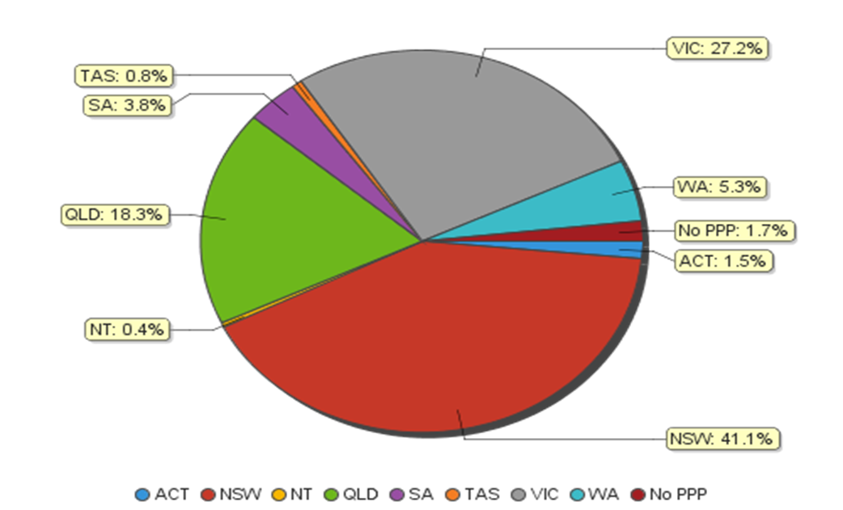

- Registration Divisions
  - Registrations by Division
Divisions | ACT | NSW | NT | QLD | SA | TAS | VIC | WA | No PPP | Total
Acupuncturist | 26 | 449 | 12 | 578 | 103 | 24 | 441 | 98 | 13 | 1,744
Acupuncturist and Chinese Herbal Dispenser |  |  |  | 2 |  |  |  |  |  | 2
Acupuncturist and Chinese Herbal Dispenser and Chinese Herbal Medicine Practitioner | 8 | 490 |  | 50 | 10 | 2 | 138 | 29 | 11 | 738
Acupuncturist and Chinese Herbal Medicine Practitioner | 36 | 936 | 5 | 224 | 65 | 11 | 671 | 121 | 50 | 2,119
Chinese Herbal Dispenser |  | 35 |  | 1 | 1 |  | 4 | 2 | 1 | 44
Chinese Herbal Dispenser and Chinese Herbal Medicine Practitioner |  | 11 |  |  | 2 |  | 2 |  | 1 | 16
Chinese Herbal Medicine Practitioner |  | 16 |  | 7 |  |  | 24 |  | 3 | 50
Total | 70 | 1,937 | 17 | 862 | 181 | 37 | 1,280 | 250 | 79 | 4,713

Age Group
- Registration Type
  - Registration type by Age Group
Age Group | General | Non-practising | Total
U - 25 | 29 | 2 | 31
25 - 29 | 250 | 13 | 263
30 - 34 | 397 | 34 | 431
35 - 39 | 599 | 29 | 628
40 - 44 | 627 | 32 | 659
45 - 49 | 540 | 17 | 557
50 - 54 | 640 | 21 | 661
55 - 59 | 592 | 28 | 620
60 - 64 | 453 | 19 | 472
65 - 69 | 231 | 14 | 245
70 - 74 | 78 | 3 | 81
75 - 79 | 45 | 3 | 48
80+ | 16 | 1 | 17
Total | 4,497 | 216 | 4,713

  - Registrants by Age Group
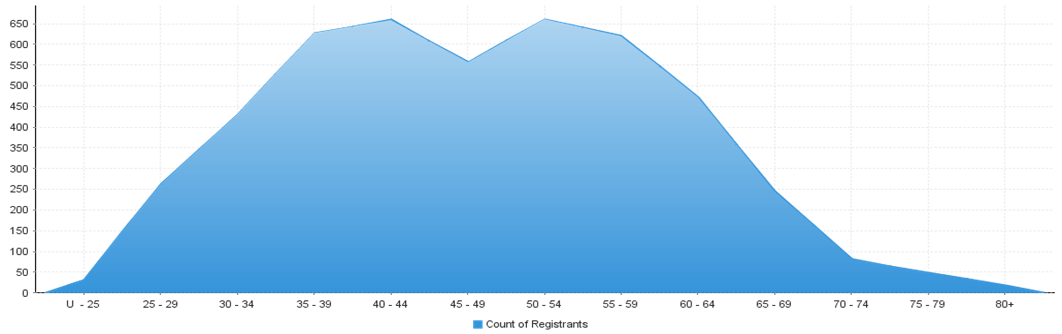

Gender
- Registration Type
  - Registration type by gender
Gender | Registration Type | ACT | NSW | NT | QLD | SA | TAS | VIC | WA | No PPP | Total
Female | General | 37 | 999 | 10 | 424 | 95 | 23 | 661 | 149 | 17 | 2,415
 | Non-practising |  | 31 |  | 35 | 2 | 1 | 51 | 3 | 16 | 139
Total Female |  | 37 | 1,030 | 10 | 459 | 97 | 24 | 712 | 152 | 33 | 2,554
Male | General | 33 | 895 | 7 | 391 | 82 | 13 | 544 | 97 | 20 | 2,082
 | Non-practising |  | 12 |  | 12 | 2 |  | 24 | 1 | 26 | 77
Total Male |  | 33 | 907 | 7 | 403 | 84 | 13 | 568 | 98 | 46 | 2,159
Total |  | 70 | 1,937 | 17 | 862 | 181 | 37 | 1,280 | 250 | 79 | 4,713

- Percentage
  - Registration by Gender Percentages
Gender | ACT | NSW | NT | QLD | SA | TAS | VIC | WA | No PPP | Total
Female | 52.86% | 53.18% | 58.82% | 53.25% | 53.59% | 64.86% | 55.63% | 60.80% | 41.77% | 54.19%
Male | 47.14% | 46.82% | 41.18% | 46.75% | 46.41% | 35.14% | 44.38% | 39.20% | 58.23% | 45.81%

