Chinese Medicine health practitioner registrant data: March 2015
Published May 2015

Introduction
The functions of the Chinese Medicine Board of Australia (the Board) include:
- registering the Chinese medicine practitioners and students
- developing standards, codes and guidelines for the Chinese Medicine profession
- handling notifications, complaints, investigations and disciplinary hearings
- overseeing the assessment of overseas trained practitioners who wish to practise in Australia, and
approving accreditation standards and accredited courses of study.
The Board’s functions are supported by the Australian Health Practitioner Regulation Agency (AHPRA). For information about legislation governing our operations see AHPRA's Legislation & Publications at www.ahpra.gov.au/Publications
The Board has analysed its registration data and produced a number of statistical breakdowns about registrants to share with the profession and community. The Board shares these breakdowns regularly.
For more information on Chinese Medicine registration, please see the Board’s website www.chinesemedicineboard.gov.au/Registration.aspx

Contents
Chinese Medicine health practitioners – registration type by state or territory 3
Chinese Medicine health practitioners – percentage by principal place of practice 3
Chinese Medicine health practitioners – division(s) by state or territory 4
Chinese Medicine health practitioners – registration type by age group 5
Chinese Medicine health practitioners – by age group 6
Chinese Medicine health practitioners – registration type by gender 7
Chinese Medicine health practitioners – percentage by gender 7

Chinese Medicine health practitioners – registration type by state or territory
Chinese Medicine Practitioner | Principal place of practice
Registration type | ACT | NSW | NT | QLD | SA | TAS | VIC | WA | No PPP | Total
General | 67 | 1,759 | 15 | 797 | 172 | 36 | 1,173 | 229 | 18 | 4,266
Non-practising | 1 | 33 |  | 34 | 2 |  | 69 | 3 | 28 | 170
Total | 68 | 1,792 | 15 | 831 | 174 | 36 | 1,242 | 232 | 46 | 4,436
Chinese Medicine health practitioners – percentage by principal place of practice

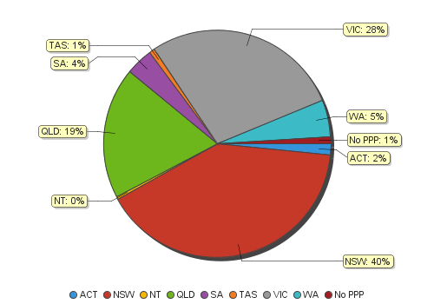
Chinese Medicine health practitioners – division(s) by state or territory
Chinese Medicine health practitioners |  | Principal place of practice
Divisions | ACT |  | NSW | NT | QLD | SA |  | TAS |  |  | VIC |  |  | WA |  |  | No PPP |  | Total
Acupuncturist | 24 |  | 425 | 11 | 563 | 100 |  | 23 |  |  | 430 |  |  | 95 |  |  | 5 |  | 1,676
Acupuncturist and Chinese Herbal Dispenser |  |  |  |  | 3 |  |  |  |  |  |  |  |  | 1 |  |  |  |  | 4
Acupuncturist and Chinese Herbal Dispenser and Chinese Herbal Medicine Practitioner | 8 |  | 394 |  | 43 | 9 |  | 2 |  |  | 113 |  |  | 24 |  |  | 4 |  | 597
Acupuncturist and Chinese Herbal Medicine Practitioner | 36 |  | 913 | 4 | 214 | 61 |  | 10 |  |  | 671 |  |  | 109 |  |  | 36 |  | 2,054
Chinese Herbal Dispenser |  |  | 34 |  | 1 | 1 |  |  |  |  | 3 |  |  | 2 |  |  |  |  | 41
Chinese Herbal Dispenser and Chinese Herbal Medicine Practitioner |  |  | 10 |  |  | 3 |  |  |  |  | 1 |  |  |  |  |  |  |  | 14
Chinese Herbal Medicine Practitioner |  |  | 16 |  | 7 |  |  | 1 |  |  | 24 |  |  | 1 |  |  | 1 |  | 50
Total | 68 |  | 1,792 | 15 | 831 | 174 |  | 36 |  |  | 1,242 |  |  | 232 |  |  | 46 |  | 4,436

Chinese Medicine health practitioners – registration type by age group
Chinese Medicine health practitioners | Registration type
Age group | General | Non-practising | Total
U - 25 | 27 |  | 27
25 - 29 | 220 | 8 | 228
30 - 34 | 361 | 23 | 384
35 - 39 | 569 | 23 | 592
40 - 44 | 601 | 26 | 627
45 - 49 | 509 | 14 | 523
50 - 54 | 616 | 19 | 635
55 - 59 | 549 | 23 | 572
60 - 64 | 446 | 16 | 462
65 - 69 | 229 | 12 | 241
70 - 74 | 80 | 2 | 82
75 - 79 | 44 | 3 | 47
80+ | 15 | 1 | 16
Total | 4,266 | 170 | 4,436

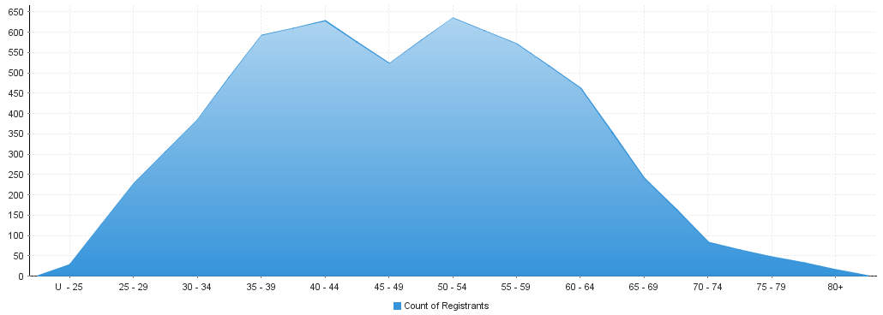
Chinese Medicine health practitioners – by age group
Age Group | U - 25 | 25 - 29 | 30 - 34 | 35 - 39 | 40 - 44 | 45 - 49 | 50 - 54 | 55 - 59 | 60 - 64 | 65 - 69 | 70 - 74 | 75 - 79 | 80+
Count of Registrants | 27 | 228 | 384 | 592 | 627 | 523 | 635 | 572 | 462 | 241 | 82 | 47 | 16

Chinese Medicine health practitioners – registration type by gender

Chinese Medicine health practitioners |  | Principal place of practice
Gender | Registration type | ACT | NSW | NT | QLD | SA | TAS | VIC | WA | No PPP | Total
Female | General | 35 | 925 | 8 | 413 | 90 | 22 | 640 | 137 | 9 | 2,279
 | Non-practising | 1 | 19 |  | 24 | 1 |  | 45 | 2 | 12 | 104
Sub Total |  | 36 | 944 | 8 | 437 | 91 | 22 | 685 | 139 | 21 | 2,383
Male | General | 32 | 834 | 7 | 384 | 82 | 14 | 533 | 92 | 9 | 1,987
 | Non-practising |  | 14 |  | 10 | 1 |  | 24 | 1 | 16 | 66
Sub Total |  | 32 | 848 | 7 | 394 | 83 | 14 | 557 | 93 | 25 | 2,053
Total |  | 68 | 1,792 | 15 | 831 | 174 | 36 | 1,242 | 232 | 46 | 4,436

Chinese Medicine health practitioners – percentage by gender
Chinese Medicine health practitioners | Principal place of practice
Gender | ACT | NSW | NT | QLD | SA | TAS | VIC | WA | No PPP | Total
Female | 52.94% | 52.68% | 53.33% | 52.59% | 52.30% | 61.11% | 55.15% | 59.91% | 45.65% | 53.72%
Male | 47.06% | 47.32% | 46.67% | 47.41% | 47.70% | 38.89% | 44.85% | 40.09% | 54.35% | 46.28%

