Chinese Medicine health practitioner registrant data: June 2015
Published August 2015

Introduction
The functions of the Chinese Medicine Board of Australia (the Board) include:
- registering the Chinese medicine practitioners and students
- developing standards, codes and guidelines for the Chinese Medicine profession
- handling notifications, complaints, investigations and disciplinary hearings
- overseeing the assessment of overseas trained practitioners who wish to practise in Australia, and
approving accreditation standards and accredited courses of study.
The Board’s functions are supported by the Australian Health Practitioner Regulation Agency (AHPRA). For information about legislation governing our operations see AHPRA's Legislation & Publications at www.ahpra.gov.au/Publications
The Board has analysed its registration data and produced a number of statistical breakdowns about registrants to share with the profession and community. The Board shares these breakdowns regularly.
For more information on Chinese Medicine registration, please see the Board’s website www.chinesemedicineboard.gov.au/Registration.aspx

Contents
Chinese Medicine health practitioners – registration type by state or territory 3
Chinese Medicine health practitioners – percentage by principal place of practice 3
Chinese Medicine health practitioners – division(s) by state or territory 4
Chinese Medicine health practitioners – registration type by age group 5
Chinese Medicine health practitioners – by age group 6
Chinese Medicine health practitioners – registration type by gender 7
Chinese Medicine health practitioners – percentage by gender 7

Chinese Medicine health practitioners – registration type by state or territory
Chinese Medicine Practitioner | Principal place of practice
Registration type | ACT | NSW | NT | QLD | SA | TAS | VIC | WA | No PPP | Total
General | 70 | 1,783 | 14 | 795 | 174 | 36 | 1,182 | 234 | 27 | 4,315
Non-practising | 1 | 37 |  | 35 | 2 | 1 | 68 | 4 | 31 | 179
Total | 71 | 1,820 | 14 | 830 | 176 | 37 | 1,250 | 238 | 58 | 4,494
Chinese Medicine health practitioners – percentage by principal place of practice

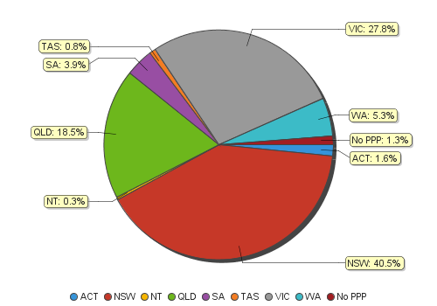
Chinese Medicine health practitioners – division(s) by state or territory
Chinese Medicine health practitioners |  | Principal place of practice
Divisions | ACT |  | NSW | NT | QLD | SA |  | TAS |  |  | VIC |  |  | WA |  |  | No PPP |  | Total
Acupuncturist | 27 |  | 426 | 10 | 560 | 102 |  | 24 |  |  | 433 |  |  | 97 |  |  | 9 |  | 1,688
Acupuncturist and Chinese Herbal Dispenser |  |  |  |  | 2 |  |  |  |  |  |  |  |  |  |  |  |  |  | 2
Acupuncturist and Chinese Herbal Dispenser and Chinese Herbal Medicine Practitioner | 8 |  | 415 |  | 43 | 9 |  | 2 |  |  | 122 |  |  | 27 |  |  | 5 |  | 631
Acupuncturist and Chinese Herbal Medicine Practitioner | 36 |  | 919 | 4 | 217 | 62 |  | 11 |  |  | 667 |  |  | 112 |  |  | 40 |  | 2,068
Chinese Herbal Dispenser |  |  | 34 |  | 1 | 1 |  |  |  |  | 3 |  |  | 2 |  |  |  |  | 41
Chinese Herbal Dispenser and Chinese Herbal Medicine Practitioner |  |  | 10 |  |  | 2 |  |  |  |  | 1 |  |  |  |  |  | 1 |  | 14
Chinese Herbal Medicine Practitioner |  |  | 16 |  | 7 |  |  |  |  |  | 24 |  |  |  |  |  | 3 |  | 50
Total | 71 |  | 1,820 | 14 | 830 | 176 |  | 37 |  |  | 1,250 |  |  | 238 |  |  | 58 |  | 4,494

Chinese Medicine health practitioners – registration type by age group
Chinese Medicine health practitioners | Registration type
Age group | General | Non-practising | Total
U - 25 | 38 | 1 | 39
25 - 29 | 245 | 7 | 252
30 - 34 | 392 | 27 | 419
35 - 39 | 591 | 29 | 620
40 - 44 | 606 | 23 | 629
45 - 49 | 512 | 14 | 526
50 - 54 | 615 | 21 | 636
55 - 59 | 565 | 23 | 588
60 - 64 | 421 | 16 | 437
65 - 69 | 199 | 12 | 211
70 - 74 | 81 | 2 | 83
75 - 79 | 38 | 3 | 41
80+ | 12 | 1 | 13
Total | 4,315 | 179 | 4,494

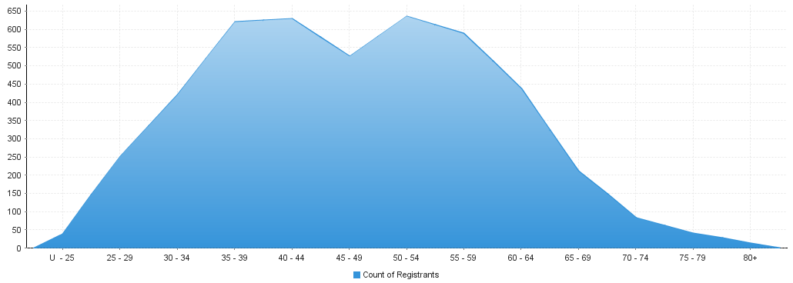
Chinese Medicine health practitioners – by age group
Age Group | U - 25 | 25 - 29 | 30 - 34 | 35 - 39 | 40 - 44 | 45 - 49 | 50 - 54 | 55 - 59 | 60 - 64 | 65 - 69 | 70 - 74 | 75 - 79 | 80+
Count of Registrants | 39 | 252 | 419 | 620 | 629 | 526 | 636 | 588 | 437 | 211 | 83 | 41 | 13

Chinese Medicine health practitioners – registration type by gender

Chinese Medicine health practitioners |  | Principal place of practice
Gender | Registration type | ACT | NSW | NT | QLD | SA | TAS | VIC | WA | No PPP | Total
Female | General | 37 | 939 | 7 | 411 | 92 | 22 | 645 | 140 | 12 | 2,305
 | Non-practising | 1 | 22 |  | 26 | 1 | 1 | 44 | 3 | 12 | 110
Sub Total |  | 38 | 961 | 7 | 437 | 93 | 23 | 689 | 143 | 24 | 2,415
Male | General | 33 | 844 | 7 | 384 | 82 | 14 | 537 | 94 | 15 | 2,010
 | Non-practising |  | 15 |  | 9 | 1 |  | 24 | 1 | 19 | 69
Sub Total |  | 33 | 859 | 7 | 393 | 83 | 14 | 561 | 95 | 34 | 2,079
Total |  | 71 | 1,820 | 14 | 830 | 176 | 37 | 1,250 | 238 | 58 | 4,494

Chinese Medicine health practitioners – percentage by gender
Chinese Medicine health practitioners | Principal place of practice
Gender | ACT | NSW | NT | QLD | SA | TAS | VIC | WA | No PPP | Total
Female | 53.52% | 52.80% | 50.00% | 52.65% | 52.84% | 62.16% | 55.12% | 60.08% | 41.38% | 53.74%
Male | 46.48% | 47.20% | 50.00% | 47.35% | 47.16% | 37.84% | 44.88% | 39.92% | 58.62% | 46.26%

