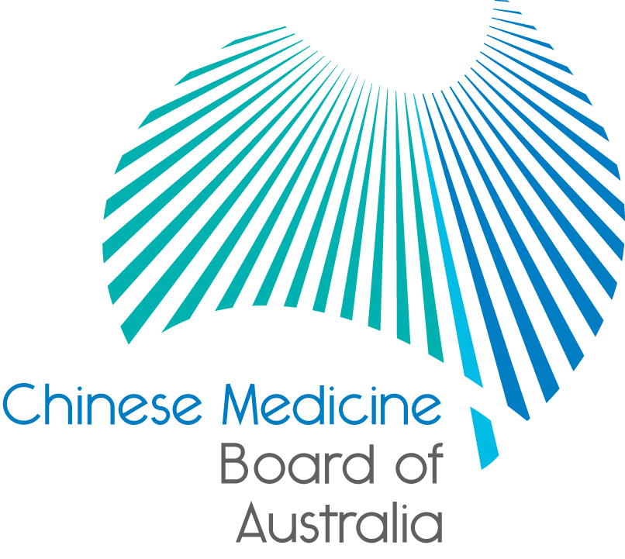

Communiqué: Chinese Medicine Board of Australia

March 2019 meeting

The 83rd meeting of the Chinese Medicine Board of Australia (the Board) was held on 26 March 2019 in Melbourne. The Board did not hold a meeting in January.

This communiqué provides details on the main decisions made at the meeting. It is also published on the Board’s [website](http://www.chinesemedicineboard.gov.au/) and an announcement via email is sent to a broad range of stakeholders. Please forward the communiqué to colleagues who may be interested in the Board’s work.

Chinese Medicine Reference Group

The Board recently decided to add a recent graduate member to the Chinese Medicine Reference Group (reference group) and a call for applications is due to close on Friday 29 March.

National Scheme news

Have your say: How should we define ‘cultural safety’?

Australian Health Practitioner Regulation Agency (AHPRA), the National Boards and Accreditation Authorities in the National Registration and Accreditation Scheme (the National Scheme) which regulates registered health practitioners in Australia have partnered with Aboriginal and Torres Strait Islander health leaders and the National Health Leadership Forum (NHLF) to release a [public consultation](https://www.ahpra.gov.au/News/Consultations.aspx).

Together, they are seeking feedback on a proposed definition of ‘cultural safety’ to develop an agreed, national baseline definition that can be used as a foundation for embedding cultural safety across all functions in the National Scheme and for use by the NHLF.

In total, there are 44 organisations represented in this consultation, which is being coordinated by the Aboriginal and Torres Strait Islander Health Strategy Group (the Strategy Group), which is convened by AHPRA, and the NHLF.

The consultation is a continuation of the work by the National Scheme’s Strategy Group that has achieving health equity for Aboriginal and Torres Strait Islander Peoples as its overall goal. Members of the Group include Aboriginal and Torres Strait Islander health leaders and members from AHPRA, National Boards, Accreditation Authorities and NSW Councils.

The six-week consultation is open to the public. Everyone interested in helping to shape the definition of ‘cultural safety’ that will be used in the National Scheme and by NHLF members is warmly invited to share their views.

The [consultation](https://www.ahpra.gov.au/News/Consultations.aspx) is open until 5:00pm, Wednesday 15 May 2019.

Help define this important term for the National Scheme. For more information read the [media release](https://www.ahpra.gov.au/News/2019-04-03-cultural-safety.aspx) on the AHPRA website.

Titles in health advertising – how to get it right

A new resource to help practitioners understand their legal obligations when using titles in health advertising addresses the uncertainty some Chinese medicine practitioners might have around this issue.

Misuse of a protected title, specialist title or endorsements is an offence under sections 113-119 of the National Law or may constitute behaviour for which health, conduct or performance action may be taken against a registered health practitioner under Part 8 of the National Law.

However, advertisers should also be aware that while use of some titles may not necessarily breach title protections under sections 113-119, they may be considered false, misleading or deceptive under the advertising provisions in the National Law (section 133).

The titles tool will help practitioners understand how titles can be used in advertising. It also outlines some of the common pitfalls that can result in titles being considered misleading under the National Law.

The titles tool is the latest in a series of [resources and support materials](http://www.ahpra.gov.au/Publications/Advertising-resources/Check-and-correct.aspx) developed by AHPRA and National Boards to help health practitioners, healthcare providers and other advertisers of regulated health services check and correct their advertising so it complies with the National Law.

The [titles tool](https://www.ahpra.gov.au/Publications/Advertising-resources/Check-and-correct/Titles.aspx) is available in the Advertising resources section of the AHPRA website.

**COAG Health Council communiqué**

The COAG Health Council met on Friday 8 March in Adelaide. Items of relevance included a plan to develop a medical workforce strategy, a briefing on the Dental Board of Australia’s proposed revised scope of practice standard, cultural safety for health professionals, and; options for a nationally consistent approach to the regulation of spinal manipulation of children. A copy of the Communique can be accessed [here](https://www.coaghealthcouncil.gov.au/Portals/0/Final%20CHC%20Communique%20080319_1.pdf).

Updating your contact details

To check or update the contact details you have lodged with AHPRA, access the online services panel for practitioners on the [home page](http://www.chinesemedicineboard.gov.au/) of the Board’s website and click *Update your contact details*. Enter your user ID, date of birth and password (please note that your user ID is not your registration number). If you can’t remember your user ID or password, [contact us online](https://www.ahpra.gov.au/About-AHPRA/Contact-Us/Make-an-Enquiry.aspx), or phone 1300 419 495 for help.

Follow AHPRA on social media

Connect with AHPRA on [Facebook](https://www.facebook.com/ahpra.gov.au/), [Twitter](https://twitter.com/AHPRA) or [LinkedIn](https://www.linkedin.com/company/australian-health-practitioner-regulation-agency) to receive information about important topics for your profession and participate in the discussion.

|  |  |  |
| --- | --- | --- |
| [cid:image001.png@01D29412.B22B9AD0](https://www.facebook.com/ahpra.gov.au/) | [cid:image002.png@01D29412.B22B9AD0](https://twitter.com/AHPRA) | [cid:image003.png@01D29412.B22B9AD0](https://www.linkedin.com/company/australian-health-practitioner-regulation-agency) |

Important information for practitioners

The Board publishes a range of information about registration, including its expectations of practitioners, at [www.chinesemedicineboard.gov.au](http://www.chinesemedicineboard.gov.au).

For more details or help with questions about your registration, notifications or other matters relevant to the National Scheme, refer to information published on [www.ahpra.gov.au](http://www.ahpra.gov.au) or [contact AHPRA](http://www.ahpra.gov.au/About-AHPRA/Contact-Us.aspx), send an [online enquiry form](https://www.ahpra.gov.au/About-AHPRA/Contact-Us/Make-an-Enquiry.aspx) or call on 1300 419 495.

Distinguished Professor Charlie C. Xue

Chair

Chinese Medicine Board of Australia

26 March 2019

*The* [*Chinese Medicine Board of Australia*](http://www.chinesemedicineboard.gov.au/) *is the regulator of Chinese medicine practitioners in Australia and acts to protect the public by ensuring that suitably qualified and competent Chinese medicine practitioners are registered. The Board is responsible for developing registration standards, codes and guidelines for Chinese medicine practitioners and managing notifications (complaints)* about Chinese medicine practitioners and Chinese medicine students. The Board does this through its powers under the Health Practitioner Regulation National Law (the National Law), as in force in each state and territory, and the National Registration and Accreditation Scheme (the National Scheme), supported by the Australian Health Practitioner Regulation Agency (AHPRA). The Board’s work in regulating Australia’s Chinese medicine practitioners in the public interest is underpinned by* [*regulatory principles*](https://www.ahpra.gov.au/About-AHPRA/Regulatory-principles.aspx)*, which encourage a responsive, risk-based approach to regulation.*

*\*Except in NSW and QLD, which have co-regulatory arrangements.*