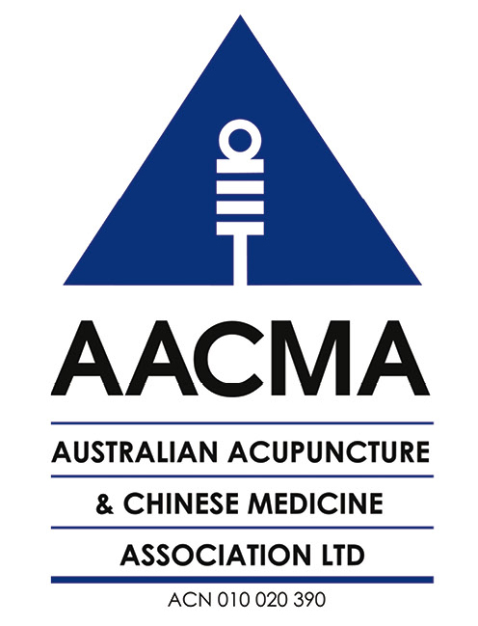
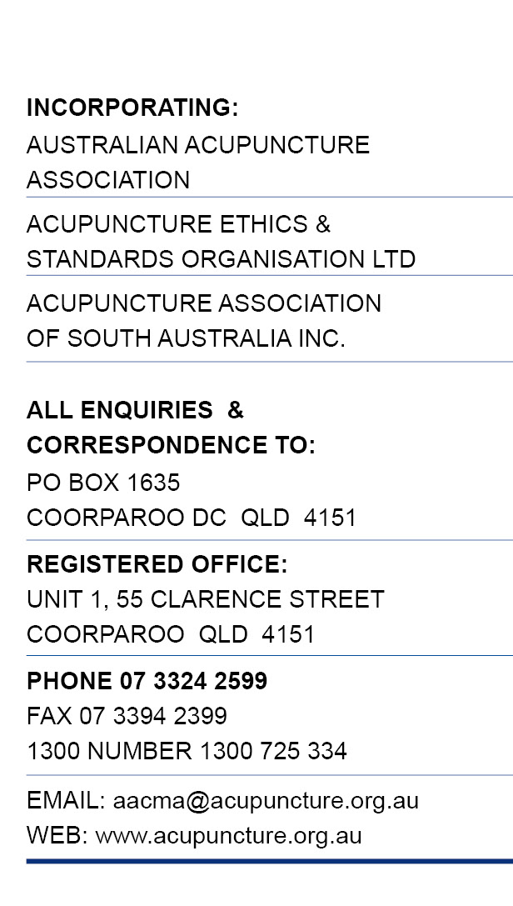
16 February 2015

The Executive Officer
Chinese Medicine Board of Australia
chinesemedicineconsultation@ahpra.gov.au

Re: Consultation on Limited Registration Standard for Teaching or Research

Thank you for providing the opportunity to comment on the Draft Registration Standard: Limited Registration for teaching or research.

RECOMMENDED OPTION

The AACMA Board supports Option 2 – Develop a standard. This provides for certainty and consistency in administration of limited registration and brings the CMBA into line with other registered health professions.

OTHER ISSUES FOR CONSULTATION

Question 1: Agree

Question 2: Agree

Question 3: Yes – see comments below

Question 4: Agree

Question 5: Agree, subject to the comments below

Question 6: Not specifically

Question 7: Three years

Question 8: Yes, see below.

Purpose of registration

It is understood that the primary purpose of limited registration is protection of the public (such as subjects in a clinical trial) or standards of education (such as theoretical and practical teachers and clinical supervisors in approved Chinese medicine programs).

However, it is clear from the daft standard that Chinese medicine teachers/lecturers in Board approved programs do not actually need any form of registration, particularly for courses that involve no specific practical or clinical components. This is a matter that needs to be considered further in relation to both general registration and limited registration.

Provision of continuing professional development – overseas presenters

All registered Chines medicine practitioners are required to complete 20 hours of Continuing Professional Development (CPD) each year.

An increasingly important aspect of CPD is the delivery of CPD activities, in Australia or online, by overseas practitioners and academics from a wide range of educational and clinical backgrounds. This includes conferences in Australia involving overseas speakers/presenters as well as seminars, lectures and workshops including both theoretical and clinical training.

We acknowledge that an attempt has been made to clarify in the draft standard that it does not apply in certain circumstances such as some training/CPD activities. However, we believe that there is still a large grey area whether providers of CPD activities in Australia (mainly, presenters from overseas and non-approved primary qualifying training) are expected to be registered.

The most common scenarios that may be captured (either intentionally or by default) by this standard are:
- CPD activities involving demonstration and training in practical techniques, clinical application of Chinese herbs and the provision of advice on specific patient conditions in the context of a seminar/workshop attended by registered Chinese medicine practitioners and students;
- Workshops and seminars intended to train non-Chinese medicine practitioners in acupuncture or Chinese herbal medicine practice, where the provider is holding out to have expertise and be qualified in these practices.

We believe the former should not require the overseas practitioner to be registered as the purpose is CPD and not primary qualifying training.

In contrast, the latter scenario is clearly intended to train unqualified persons in the practice of acupuncture or Chinese herbal medicine outside a Board-approved program of study. Claims to be qualified to provide such training would in itself be a breach of the holding out provisions or at best be a breach of professional standards by a registered practitioner.

While these matters may be intended to be outside the draft standard, they are still relevant to the scope of the draft standard or at least to the absence of an applicable standard. We think that a position statement on these related issues needs to be developed to remove confusion.

Claims by overseas presenters having special expertise

A side-issue has been raised about claims to special expertise by overseas presenters and whether this may or may not breach the CMBA Advertising Guidelines. The draft standard makes it clear that protected titles should not be used and that any overseas accreditations or registrations must be clearly stated.

Further dialogue is needed on this issue and guidelines developed for overseas presenters and local advertisers since the individuals concerned would not be CMBA-registered practitioners. AACMA will give this issue further consideration and prepare a submission to the CMBA on this issue at a later date.

Please contact me at the AACMA national office if you wish to discuss the contents of this submission.

Yours faithfully

Judy James
Acting AACMA CEO

