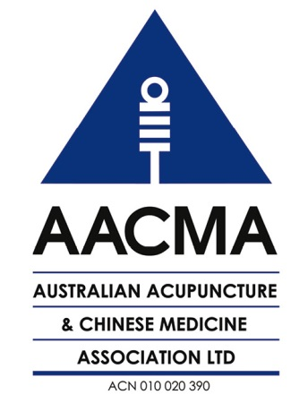
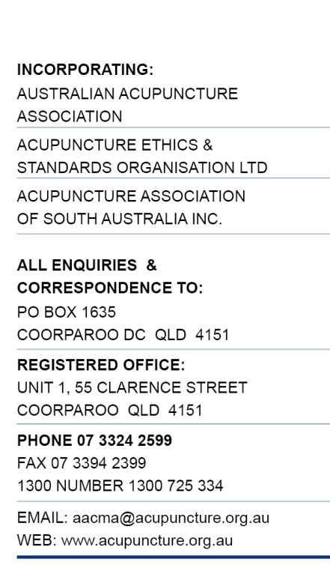

4 July 2014

Chinese Medicine Board of Australia
E: chinesemedicineconsultation@ahpra.gov.au

Re: Consultation on Draft Guidelines for safe Chinese herbal medicine practice

Thank you for the opportunity to provide feedback on the draft Guidelines for safe Chinese herbal medicine practice. (Guidelines).

We congratulate the Board for the hard work and professionalism demonstrated in the approach taken by placing public health and safety as the priority. In particular, the forward-looking approach of recommending the botanical name be used as the herb identifier. Practitioners need to know that the species of herbs that are prescribed for a patient are the species of herbs that are dispensed. It is equally important that the correct herb name is supplied at all steps in the supply chain.

The guidelines will require a change in prescribing and dispensing practices, and a suitable lead-in time is both necessary and welcome.

AACMA supports Option 3 (a new guideline) as it has been developed in the contemporary national context.

Our response to the specific questions is outlined below:

QUESTION RESPONSES

- Do you agree that these guidelines apply to all medicines prescribed and/or dispensed by Chinese medicine practitioners?

Response: Yes

The guidelines should apply to all prescribed and/or dispensed medicines, not just Chinese herbal prescriptions. It would be inconsistent and counterproductive to have a different lower standard for other product.

- TGA nomenclature guidelines require the botanical name to be used for herbal products in manufactured medicines. Pinyin and/or Chinese characters are more commonly used for Chinese herbal medicine prescription writing and dispensing. The use of Chinese characters alone makes it difficult for patients and other health practitioners to understand what medicine the patient is taking. For Chinese herbal medicine prescription writing, do you agree that pinyin or the pharmaceutical name should be used as an alternative to the botanical name, with the addition of Chinese characters where necessary? Is this guideline practical to implement? If you disagree, what alternatives do you suggest?

Response: Yes.

Using the botanical name means that the exact species is identified and minimises errors in the particular herb name or part used as well as inadvertent substitution. Unfortunately, it will not address unauthorised substitution and mislabelling of wholesale product.

The pinyin name, in addition to botanical name, may be useful to facilitate communication with third party dispensers but should not be relied on as the primary identifier of the herb. Chinese herbal dispensers must be cognisant of, rely on, and use the botanical name on all dispensed product.

- Zhao et al (2006) identified that up to 27 per cent of Chinese herbs are sourced from multiple species, making it impossible to accurately identify the species used if the herb is identified only by pinyin, Chinese characters or pharmaceutical name. Best practice is to label herbs supplied to a patient by the botanical name to allow for accurate reference to drug-herb interaction databases, accurate tracking of potential adverse events and the informed use of evidence from pharmacological research. Do you agree that herbs should be labelled according to their botanical name? If not what alternative do you recommend to address these safety issues and remove ambiguity in labelling?

Response: Yes.

For the reasons stated, labels should include the botanical names of all ingredients.

- Are the labelling requirements practical to implement?

Response: Yes.

However, this will require ongoing support from the CMBA in ensuring an up-to-date list of herb botanical names and related pinyin, character and pharmaceutical names for cross referencing is available for practitioners, dispensers and the public.

The second issue is that practitioners and dispensers may need to move to electronic prescription writing (if they have not already done so) and invest in suitable printing technology (such as label printers). This will have a cost impact but may result in time-savings over the longer term.

- Is the required information for prescriptions appropriate?

Response: Yes.

- Do you agree with the circumstances in which a medicine may be supplied for self-medication?

Response: Yes, for TGA-listed and non-restricted TGA-registered product.

For raw/unprocessed herbs and mixed herbal formulas, there needs to be a clear delineation between check-listing for safety purposes and venturing in the realm of a Chinese herbal consultation. It is not appropriate for the dispenser to dispense any unsafe product or to suggest a substitute formula. If the dispenser has any concerns about the appropriateness of the self-prescribed formula (or an unsigned prescription), then the dispenser should decline to fill the prescription and instead refer the person to a registered Chinese herbal medicine practitioner.

- Do you agree with the limited role of dispensary assistants as outlined in section 5 of the guidelines?

Response: Yes.

- Are there any additional requirements which should apply to the management of a Chinese herbal dispensary?

Response: Yes.

Occupational health and safety requires that dispensers wear adequate protective gear when preparing herbal formulas (such as when powdering, crushing, etc) as part of the dispensing process. Please see comments below about herbal safety standards.

- Does the sample label and prescription assist in understanding the requirements set out in the guidelines? Should any other examples be used?

Response: An additional example is required.

For a medicine intended for topical application, an example should be given where it states ‘For External Use Only’.

- Taken as a whole, are the guidelines practical to implement and sufficient for safe practice?

Response: Yes; See also our statement below regarding safety standards.

- Is the content flow and structure of the guideline helpful, clear, relevant and workable?

Response: Yes

- Is there any content that needs to be changed or deleted?

Response: There are minor typographical errors that need to be corrected.

- Is there anything missing that needs to be added?

Response: Yes. Please see additional comments below.

- Do you agree with the proposed 12-month transition period and if so is this period adequate?

Response: No, it should be 24 months.

It is our understanding that individual herbs are already imported using the botanical name, therefore this should not pose a major problem for wholesalers and importers in labelling bulk herbs with the botanical name.

For dispensers, this will require significant change in practices and use of technology for which a 24 month transition period will be necessary.

The reason for seeking a 24 month transition period is twofold:
- Practitioners will need to upgrade to electronic prescriptions and labelling, as opposed to the handwritten methods still predominantly in use – time will be needed to look at the technology options suitable to the Australian context to facilitate compliance
- this policy will also require the development of educational materials and training arrangements to assist practitioners and dispensers with compliance, particularly for those practitioners who were registered without qualifications under the grandparenting standard and those who are not familiar with the terminology of botanical names.

- Should the review period for the guidelines be two, three or five years?

Response: A review at three years is recommended.

- Do you have any other comments on the draft guideline?

Response: Yes. Please see comments below.

OTHER ISSUES

Safety standards for Chinese herbal medicine

There are related issues that need to be addressed either in these Guidelines or in another Code/Guideline relating to safety standards in Chinese herbal dispensing.

These issues, which relate to occupation health and safety and disease prevention, are:
- That staff are to use protective masks and safety glasses during certain preparation methods (paozhi) such as grinding which may result in inhalable airborne particles;
- That supply of untreated/unprocessed ground herbs in powder or capsule form may be a health risk and that raw/unprocessed herbs be subject to some form of heat treatment, such as the decoction processes, to kill micro-organisms that may be present in the herbs.,

Interface between national registration, TGA and cross-border dispensing

AACMA understands that the exemption from the manufacturing provisions of the Therapeutic Goods Act/Regulations applies to extemporaneously mixed and dispensed product.

The question is: does national registration as a Chinese herbal dispenser override the requirement for a dispenser to be a licensed manufacturer when sending mixed product over state/territory borders?

An issue that has been prevalent is the movement of mixed medicines across state boundaries. Written advice to AACMA from the TGA prior to national registration has clearly stated that unless the sender is a licensed manufacturer they would be in contravention relevant Act/Regulation. Businesses that sought to provide a cross-border dispensing service were directed by the TGA to desist or risk prosecution unless they were a licensed manufacturer.

Therefore, we ask that the CMBA look into this issue further and seek advice to clarify the status of cross-border dispensing in the context of national registration of Chinese herbal dispensers.

Standards for e-prescriptions

The use of e-health methods for third party Chinese herbal dispensing is already in place in sections of the Chinese medicine profession. Work needs to be done to set minimum standards for e-dispensing, including security and privacy issues.

A related issue is incorporating Chinese herbal prescriptions into the Personally Controlled Electronic Health Record (PCEHR). Clearly, this is not a short-term priority, would not occur before the 12 (or 24) month transitional period, and would require widespread adherence to appropriate record keeping standards and agreed Chinese medicine terminology/informatics to be in place.

Further information

Please contact AACMA on ceo@acupuncture.org.au if you have any questions about this submission.

Yours faithfully

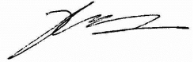
Prof Hong Xu
AACMA President

Watson K. Safety guidelines for Chinese herbal dispensing. J Aust Tradit-Med So. 2004;10(3):1–4.
Bensoussan A & Myers S. Towards a Safer Choice: The Practice of Traditional Chinese Medicine in Australia. 1997. Sydney: University of Western Sydney; p.69.

