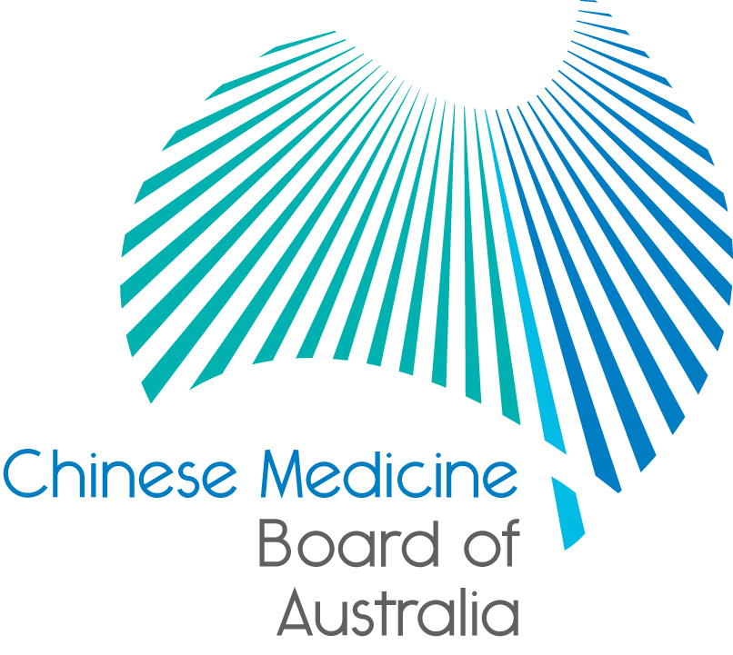

Communiqué: Chinese Medicine Board of Australia

September 2019 meeting

The 89th meeting of the Chinese Medicine Board of Australia (the Board) was held on 24 September 2019 in Melbourne.

This communiqué provides details on the main decisions made at the meeting. It is also published on the Board’s [website](http://www.chinesemedicineboard.gov.au/) and an announcement via email is sent to a broad range of stakeholders. Please forward the communiqué to colleagues who may be interested in the Board’s work.

Board meets with President of the Chinese Medicine Council of New South Wales

In September 2019, the Board met with Professor Danforn Lim, President of the Chinese Medicine Council of New South Wales (the Council). During the meeting, the Board and Professor Lim discussed similarities and differences in the management of notifications about Chinese medicine practitioners in the two jurisdictions.

Outcomes of the meeting included a commitment to further improve ongoing contact between the Board and the Council and to strengthen the co-regulatory relationship by:

* establishing a regular schedule of meetings between the Board and the Council, and
* sharing resources, where possible, to reduce duplication and potential for confusion about the roles of the Board and the Council.

Board sets registration fee for 2019/20

The registration fee for Chinese medicine practitioners has been frozen, the fee for one, two or three divisions remains at $579, $685 and $737 respectively. The fee for practitioners whose principal place of practice is New South Wales[1] is the same as the National fee. A full [fee schedule](https://www.chinesemedicineboard.gov.au/Registration/Fees.aspx) is published on the Board’s website.

The National Scheme is funded by health practitioners’ registration fees. More detailed information about the Board’s financial operations is outlined in the health profession agreement between the Board and AHPRA for 2016/20, which is published on the Board’s [website](https://www.chinesemedicineboard.gov.au/About/Health-Profession-Agreements.aspx).

Important consultations now open – feedback invited

Three public consultations are now open asking for people to have their say on revised guidance to help practitioners and others understand their mandatory notification obligations, understand their obligations when advertising a regulated health service and to support a responsive and risk-based approach to supervised practice

The Board is conducting the consultations alongside other National Boards and AHPRA on:

* revised *Guidelines: Mandatory notifications about registered health practitioners and Guidelines: Mandatory notifications about health students*
* revised *Guidelines on advertising regulated health services*, and
* a proposed *Supervised practice framework*.

The Board invites Chinese medicine practitioners and its stakeholders to provide feedback to these important public consultations. To ensure everyone has the chance to respond the closing dates for public consultation have been staggered as follows:

* Public consultation on the mandatory notifications guidelines will close on 6 November 2019.
* Public consultation on the advertising guidelines will close on 26 November 2019.
* Public consultation on the supervised practice framework will close on 17 December 2019.

The consultation papers are available on the [Consultations page](https://www.chinesemedicineboard.gov.au/News/Consultations.aspx) of the Board’s website.

Updating your contact details

To check or update the contact details you have lodged with AHPRA, access the online services panel for practitioners on the [home page](http://www.chinesemedicineboard.gov.au/) of the Board’s website and click *Update your contact details*. Enter your user ID, date of birth and password (please note that your user ID is not your registration number). If you can’t remember your user ID or password, [contact us online](https://www.ahpra.gov.au/About-AHPRA/Contact-Us/Make-an-Enquiry.aspx), or phone 1300 419 495 for help.

Follow AHPRA on social media

Connect with AHPRA on [Facebook](https://www.facebook.com/ahpra.gov.au/), [Twitter](https://twitter.com/AHPRA) or [LinkedIn](https://www.linkedin.com/company/australian-health-practitioner-regulation-agency) to receive information about important topics for your profession and participate in the discussion.

|  |  |  |
| --- | --- | --- |
| [cid:image001.png@01D29412.B22B9AD0](https://www.facebook.com/ahpra.gov.au/) | [cid:image002.png@01D29412.B22B9AD0](https://twitter.com/AHPRA) | [cid:image003.png@01D29412.B22B9AD0](https://www.linkedin.com/company/australian-health-practitioner-regulation-agency) |

Important information for practitioners

The Board publishes a range of information about registration, including its expectations of practitioners, at [www.chinesemedicineboard.gov.au](http://www.chinesemedicineboard.gov.au).

For more details or help with questions about your registration, notifications or other matters relevant to the National Scheme, refer to information published on [www.ahpra.gov.au](http://www.ahpra.gov.au) or [contact AHPRA](http://www.ahpra.gov.au/About-AHPRA/Contact-Us.aspx), send an [online enquiry form](https://www.ahpra.gov.au/About-AHPRA/Contact-Us/Make-an-Enquiry.aspx) or call on 1300 419 495.

Distinguished Professor Charlie C. Xue

Chair

Chinese Medicine Board of Australia

24 September 2019

*The* [*Chinese Medicine Board of Australia*](http://www.chinesemedicineboard.gov.au/) *is the regulator of Chinese medicine practitioners in Australia and acts to protect the public by ensuring that suitably qualified and competent Chinese medicine practitioners are registered. The Board is responsible for developing registration standards, codes and guidelines for Chinese medicine practitioners and managing notifications (complaints)* about Chinese medicine practitioners and Chinese medicine students. The Board does this through its powers under the Health Practitioner Regulation National Law (the National Law), as in force in each state and territory, and the National Registration and Accreditation Scheme (the National Scheme), supported by the Australian Health Practitioner Regulation Agency (AHPRA). The Board’s work in regulating Australia’s Chinese medicine practitioners in the public interest is underpinned by* [*regulatory principles*](https://www.ahpra.gov.au/About-AHPRA/Regulatory-principles.aspx)*, which encourage a responsive, risk-based approach to regulation.*

*\*Except in NSW and QLD, which have co-regulatory arrangements.*

1. 1NSW is a co-regulatory jurisdiction. 