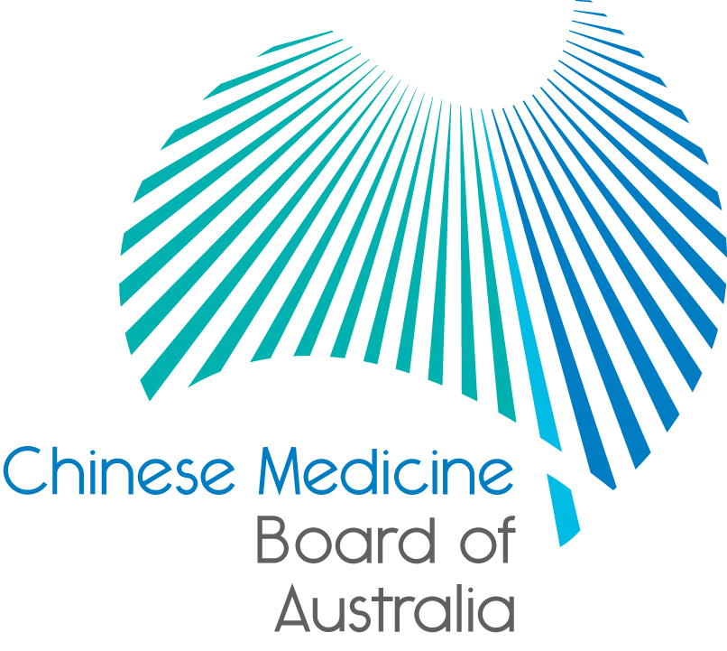

Communiqué: Chinese Medicine Board of Australia

December 2016 meeting
The 61st meeting of the Chinese Medicine Board of Australia (the Board) was held on 13 December 2016 in Melbourne.
At this meeting the Board received reports from guests:
- Chair of the Chinese Medicine Accreditation Committee (CMAC), Dr Meeuwis Boelen, and
- President of the Chinese Medicine Council of NSW, Associate Professor Chris Zaslawski.

The Board wishes everyone a safe and healthy Christmas holiday period.
This communiqué provides key decisions made at the meeting. It is also published on the Board’s website and an announcement via email is sent to a broad range of stakeholders. Please forward the communiqué to colleagues who may be interested in the work of the Board.
Renewal of registration – late applications
Renewal of registration for Chinese medicine practitioners ended on 30 November 2016.
If you have not yet renewed, you can still apply up until 31 December 2016, however, you will have to pay a late fee.
The quickest and easiest way to renew your registration is online. You can keep practising during the late period but must apply for renewal by 31 December.
Under the National Law, if you do not apply to renew your registration within one month of your registration expiry date, your registration will lapse and your name will be removed from the Register of Chinese medicine practitioners. This means you cannot practise in Australia until a new application for registration is approved.
If you wish to practise you must make a new application for registration. Fast track application forms will be available on the Board’s website under Registration/Forms during January 2017. If you are submitting a fast track application in January, you cannot practise until your application is processed and you have received confirmation from AHPRA that your application for registration has been successful.
Information about renewal, including renewal FAQ, is available on the Board’s website.
Chinese Medicine Reference Group
Members will attend the first meeting on 22 February 2017. Further information about the group is on the Board’s website.
News from AHPRA
The Board works in partnership with AHPRA and the other 13 National Boards to deliver the National Registration and Accreditation Scheme (the National Scheme).
While we publish news specific to our work in regulating Chinese medicine practitioners, AHPRA publishes updates on work from across the National Scheme. This includes communiqués from key meetings with government and other stakeholders.

We encourage you to review these from time to time. You are also able to subscribe to the AHPRA newsletter by registering here.
AHPRA Performance report July–September 2016
The July to September 2016 quarterly performance reports for the Australian Health Practitioner Regulation Agency (AHPRA) and the National Boards are now available.
The reports, which are part of an ongoing drive by AHPRA and the National Boards to increase their accountability and transparency, include data specific to each state and territory.
Each report covers AHPRA and the National Boards’ main areas of activity:
- managing applications for registration as a health practitioner
- managing notifications about the health, performance and conduct of registered health practitioners and offences against the National Law, and
- monitoring health practitioners and students with restrictions on their registration.
The reports are available on the Statistics page.
To provide feedback on the reports please email: reportingfeedback@ahpra.gov.au.
Updating your contact details
To check or update the contact details you have lodged with AHPRA, access the online services panel for practitioners on the homepage of the Board’s website and click Update your contact details. Enter your user ID, date of birth and password (please note that your user ID is not your registration number). If you don’t remember your user ID or password, contact us online or phone 1300 419 495 for help.
Follow @AHPRA on Twitter
AHPRA uses Twitter to encourage a greater overall response to National Board consultations and to host regular Twitter chats on important topics.
Important information for practitioners
The Board publishes a range of information about registration, including its expectations of practitioners, at www.chinesemedicineboard.gov.au.
For more details or help with questions about your registration, notifications or other matters relevant to the National Scheme, refer to information published on www.ahpra.gov.au or contact AHPRA, send an online enquiry form or call on 1300 419 495.
Professor Charlie C Xue
Chair, Chinese Medicine Board of Australia
29 December 2016

The Chinese Medicine Board of Australia is the regulator of Chinese medicine practitioners in Australia and acts to protect the public by ensuring that suitably qualified and competent Chinese medicine practitioners are registered. The Board is responsible for developing registration standards, codes and guidelines for Chinese medicine practitioners and managing notifications (complaints)* about Chinese medicine practitioners and Chinese medicine students. The Board does this through its powers under the Health Practitioner Regulation National Law, as in force in each state and territory, and the National Registration and Accreditation Scheme, supported by the Australian Health Practitioner Regulation Agency (AHPRA). The Board’s work in regulating Australia’s Chinese medicine practitioners in the public interest is underpinned by regulatory principles, which encourage a responsive, risk-based approach to regulation.
*Except in NSW and Qld which have co-regulatory arrangements.

