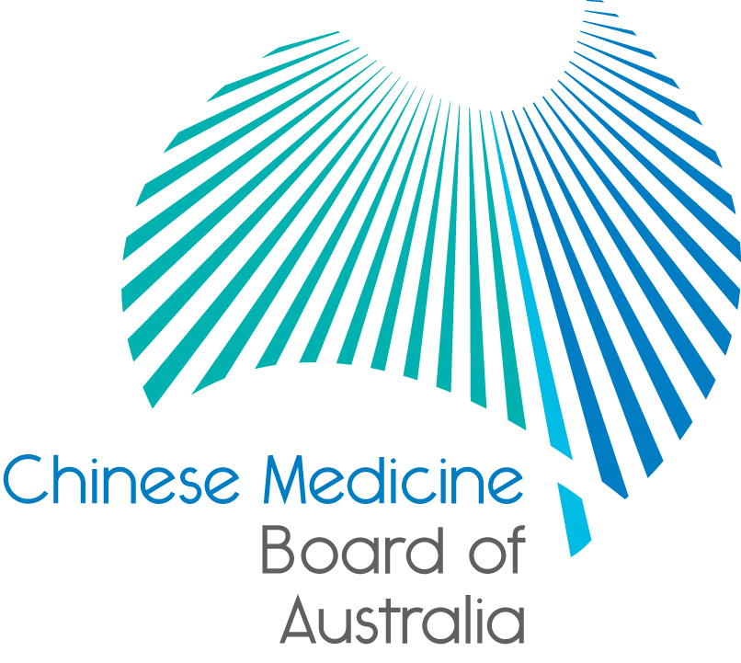

Communiqué: Chinese Medicine Board of Australia

October 2018 meeting

The 80th meeting of the Chinese Medicine Board of Australia (the Board) was held on 23 October 2018 in Melbourne.

This communiqué provides details on the main decisions made at the meeting. It is also published on the Board’s [website](http://www.chinesemedicineboard.gov.au/) and an announcement via email is sent to a broad range of stakeholders. Please forward the communiqué to colleagues who may be interested in the Board’s work.

Chinese Medicine Reference Group

Applications have closed for Chinese medicine practitioners for appointment to the Chinese Medicine Reference Group. For news and the latest vacancies on the Board’s committees, visit the [Committee member recruitment page](https://www.ahpra.gov.au/National-Boards/Statutory-Appointments/Committee-member-recruitment.aspx) on the AHPRA website.

AHPRA and National Boards welcome release of the Accreditation Systems Review final report

AHPRA and National Boards have welcomed the publication of the Independent Accreditation Systems Review final report.

The Independent Accreditation Systems Review’s (the Review) [final report](http://www.coaghealthcouncil.gov.au/Projects/Accreditation-Systems-Review) makes significant, far reaching recommendations to reform the accreditation system for regulated health professions in Australia. It proposes recommendations which range from relatively uncontentious and which the National Scheme bodies generally support, to those which are significantly more complex and contentious.

Health Ministers commissioned the Review following a [review of the National Scheme](http://www.coaghealthcouncil.gov.au/Projects/Independent-Review-of-NRAS-finalised) as a whole.

For more information read the [statement](https://www.ahpra.gov.au/News/2018-10-15-AHPRA-welcomes-release-of-the-accreditation-systems-review-final-report.aspx) on the AHPRA website.

Farewell to outgoing Board members and welcome to new members

Australian Health Ministers [recently announced](https://www.ahpra.gov.au/About-AHPRA/Ministerial-Directives-and-Communiques.aspx) new appointments and reappointments to the Chinese Medicine Board and other National Boards.

Welcome to Bing Tian, who has been appointed a practitioner member for her first term. All other current Board appointments continue, including Professor Charlie Xue, who was reappointed as Chair.

Terms on Boards are for three years and existing members can apply for reappointment.

A full list of appointments for the National Boards is available in the [Ministerial Council communique](https://www.coaghealthcouncil.gov.au/Portals/0/_Communique%20National%20Board%20Appointments_071118_1.pdf).

Updating your contact details

To check or update the contact details you have lodged with AHPRA, access the online services panel for practitioners on the [home page](http://www.chinesemedicineboard.gov.au/) of the Board’s website and click *Update your contact details*. Enter your user ID, date of birth and password (please note that your user ID is not your registration number). If you can’t remember your user ID or password, [contact us online](https://www.ahpra.gov.au/About-AHPRA/Contact-Us/Make-an-Enquiry.aspx), or phone 1300 419 495 for help.

Follow AHPRA on social media

Connect with AHPRA on [Facebook](https://www.facebook.com/ahpra.gov.au/), [Twitter](https://twitter.com/AHPRA) or [LinkedIn](https://www.linkedin.com/company/australian-health-practitioner-regulation-agency) to receive information about important topics for your profession and participate in the discussion.

|  |  |  |
| --- | --- | --- |
| [cid:image001.png@01D29412.B22B9AD0](https://www.facebook.com/ahpra.gov.au/) | [cid:image002.png@01D29412.B22B9AD0](https://twitter.com/AHPRA) | [cid:image003.png@01D29412.B22B9AD0](https://www.linkedin.com/company/australian-health-practitioner-regulation-agency) |

Important information for practitioners

The Board publishes a range of information about registration, including its expectations of practitioners, at [www.chinesemedicineboard.gov.au](http://www.chinesemedicineboard.gov.au).

For more details or help with questions about your registration, notifications or other matters relevant to the National Scheme, refer to information published on [www.ahpra.gov.au](http://www.ahpra.gov.au) or [contact AHPRA](http://www.ahpra.gov.au/About-AHPRA/Contact-Us.aspx), send an [online enquiry form](https://www.ahpra.gov.au/About-AHPRA/Contact-Us/Make-an-Enquiry.aspx) or call on 1300 419 495.

Professor Charlie Xue

Chair

Chinese Medicine Board of Australia

23 October 2018

*The* [*Chinese Medicine Board of Australia*](http://www.chinesemedicineboard.gov.au/) *is the regulator of Chinese medicine practitioners in Australia and acts to protect the public by ensuring that suitably qualified and competent Chinese medicine practitioners are registered. The Board is responsible for developing registration standards, codes and guidelines for Chinese medicine practitioners and managing notifications (complaints)* about Chinese medicine practitioners and Chinese medicine students. The Board does this through its powers under the Health Practitioner Regulation National Law (the National Law), as in force in each state and territory, and the National Registration and Accreditation Scheme (the National Scheme), supported by the Australian Health Practitioner Regulation Agency (AHPRA). The Board’s work in regulating Australia’s Chinese medicine practitioners in the public interest is underpinned by* [*regulatory principles*](https://www.ahpra.gov.au/About-AHPRA/Regulatory-principles.aspx)*, which encourage a responsive, risk-based approach to regulation.*

*\*Except in NSW and QLD, which have co-regulatory arrangements.*