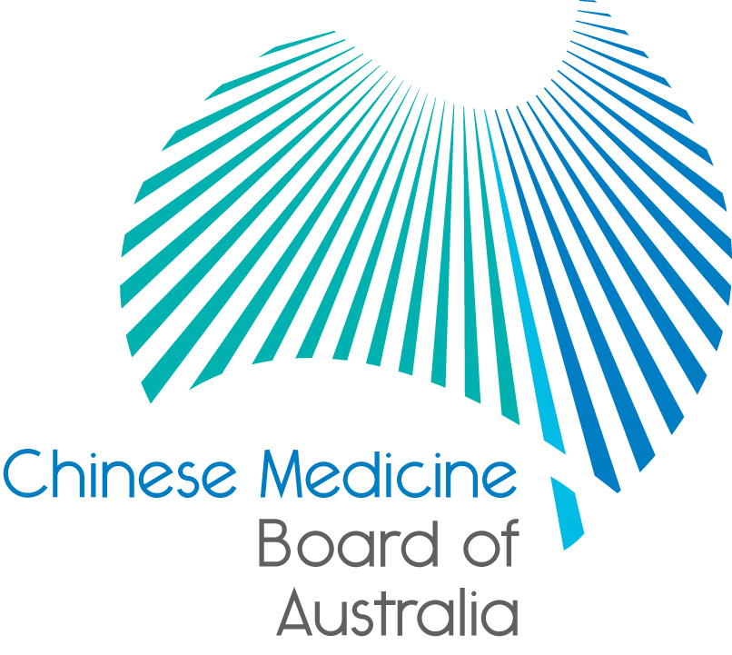

Communiqué: Chinese Medicine Board of Australia

December 2018 meeting

The 81st meeting of the Chinese Medicine Board of Australia (the Board) was held on 18 December 2018 in Melbourne. The Board did not hold a meeting in November.

This communiqué provides details on the main decisions made at the meeting. It is also published on the Board’s [website](http://www.chinesemedicineboard.gov.au/) and an announcement via email is sent to a broad range of stakeholders. Please forward the communiqué to colleagues who may be interested in the Board’s work.

Chinese Medicine Reference Group

Applications for the four practitioner member positions for the Chinese Medicine Reference Group closed on 31 October 2018 and the Board will announce the appointments in January 2019 after it has confirmed with the appointees and completed all the required paperwork.

CLEAR Asia-Pacific Regional Symposium

Since its previous meeting, eight Board members attended the Council of Licensure, Enforcement and Regulation Regional (CLEAR) symposium in Wellington, New Zealand in November 2018. The symposium examined the approaches and mechanisms used by professional and occupational regulators to demonstrate that they are serving and protecting the public interest. The symposium first looked, in a more traditional sense, at the processes and reporting of performance, and second, examining how regulators can move beyond current parameters to understand the larger influence they have on the community with their work.

Do you practise under the name published on the online register of practitioners?

Governments recently consulted on possible changes to the National Law, which would allow the Australian Health Practitioner Regulation Agency (AHPRA) and National Boards to publish on the online [register of practitioners](https://www.ahpra.gov.au/Registration/Registers-of-Practitioners.aspx), the names that registered health practitioners use in practice and not just their legal name.

The national register of practitioners is a vital part of Australia’s system of regulating Chinese medicine practitioners to support patient safety. Each registered health profession publishes registration information about practitioners on the register. The public and employers can look up the names of all health practitioners who are registered to practise. The register also provides important information about limits or restrictions placed on the way a registered health practitioner is allowed to practise.

The register must remain an authoritative and trusted source of information about health practitioners. Consumers rely on it for accurate and up to date information to inform their healthcare decision-making and employers rely on them to validate their employees’ registration status.

Read the [media release](https://www.chinesemedicineboard.gov.au/News/2018-10-29-media-release-National-register.aspx) for more information.

Paramedics: Welcome to the National Scheme!

On Saturday 1 December 2018 the National Scheme reached a milestone with paramedicine becoming the 16th regulated health profession.

Reflecting on the milestone, Paramedicine Board of Australia Chair Associate Professor Stephen Gough ASM noted that it was the culmination of many years of debate, deliberation and sustained effort by the paramedic profession to join a national regulatory scheme that has patient safety at its heart.

‘While paramedics have always had the patient at the centre of everything they do – showing compassion, understanding and empathy to those they provide care – the past two decades have also seen the profession grow in complexity; paramedics are now working in a range of roles and environments, using sophisticated treatments and technology, to provide world-class services to Australian communities.

‘Regulating paramedicine under the National Scheme acknowledges the critical role paramedics play in our health system and recognises paramedics as registered health professionals,’ Associate Professor Gough said.

1 December 2018 also marks just over two years since the [COAG Health Council](https://www.coaghealthcouncil.gov.au/Portals/0/CHC%207%20October%202016_Meeting%20Communique_1.pdf) announced its intention to regulate the paramedicine profession, with the inaugural National Board appointed in October 2017.

Read the [media release](https://www.ahpra.gov.au/News/2018-11-30-Paramedics-Welcome-to-the-National-Scheme.aspx) for more information, or find out more about paramedicine on the [Paramedicine Board of Australia’s website](https://www.paramedicineboard.gov.au/).

Updating your contact details

To check or update the contact details you have lodged with AHPRA, access the online services panel for practitioners on the [home page](http://www.chinesemedicineboard.gov.au/) of the Board’s website and click *Update your contact details*. Enter your user ID, date of birth and password (please note that your user ID is not your registration number). If you can’t remember your user ID or password, [contact us online](https://www.ahpra.gov.au/About-AHPRA/Contact-Us/Make-an-Enquiry.aspx), or phone 1300 419 495 for help.

Follow AHPRA on social media

Connect with AHPRA on [Facebook](https://www.facebook.com/ahpra.gov.au/), [Twitter](https://twitter.com/AHPRA) or [LinkedIn](https://www.linkedin.com/company/australian-health-practitioner-regulation-agency) to receive information about important topics for your profession and participate in the discussion.

|  |  |  |
| --- | --- | --- |
| [cid:image001.png@01D29412.B22B9AD0](https://www.facebook.com/ahpra.gov.au/) | [cid:image002.png@01D29412.B22B9AD0](https://twitter.com/AHPRA) | [cid:image003.png@01D29412.B22B9AD0](https://www.linkedin.com/company/australian-health-practitioner-regulation-agency) |

Important information for practitioners

The Board publishes a range of information about registration, including its expectations of practitioners, at [www.chinesemedicineboard.gov.au](http://www.chinesemedicineboard.gov.au).

For more details or help with questions about your registration, notifications or other matters relevant to the National Scheme, refer to information published on [www.ahpra.gov.au](http://www.ahpra.gov.au) or [contact AHPRA](http://www.ahpra.gov.au/About-AHPRA/Contact-Us.aspx), send an [online enquiry form](https://www.ahpra.gov.au/About-AHPRA/Contact-Us/Make-an-Enquiry.aspx) or call on 1300 419 495.

Distinguished Professor Charlie C. Xue

Chair

Chinese Medicine Board of Australia

18 December 2018

*The* [*Chinese Medicine Board of Australia*](http://www.chinesemedicineboard.gov.au/) *is the regulator of Chinese medicine practitioners in Australia and acts to protect the public by ensuring that suitably qualified and competent Chinese medicine practitioners are registered. The Board is responsible for developing registration standards, codes and guidelines for Chinese medicine practitioners and managing notifications (complaints)* about Chinese medicine practitioners and Chinese medicine students. The Board does this through its powers under the Health Practitioner Regulation National Law (the National Law), as in force in each state and territory, and the National Registration and Accreditation Scheme (the National Scheme), supported by the Australian Health Practitioner Regulation Agency (AHPRA). The Board’s work in regulating Australia’s Chinese medicine practitioners in the public interest is underpinned by* [*regulatory principles*](https://www.ahpra.gov.au/About-AHPRA/Regulatory-principles.aspx)*, which encourage a responsive, risk-based approach to regulation.*

*\*Except in NSW and QLD, which have co-regulatory arrangements.*